

MUSKRAT WATERSHED COUNCIL (MWC)
Meeting of the Board of Directors

Meeting Minutes
Thursday, April 16, 2026, 6:30 p.m.

In person: Basement of the Whitewater Township Building, 44 Main Street, Cobden ON
Online through Google Meet

meet.google.com/ezd-qitc-btk
+1 587-978-1050 (PIN 460326449)

- Welcome and Call to Order
The meeting of the Muskrat Watershed Council was called to order at 6:38 p.m.

- Introductions and Record of Attendance

Attendance:

Present: Mackenzie Baird, Rene Coulas, Barbara Green, Debbie Macdonald, Jeff Reeves, Evelyn St. Amour, Greg Stasyna, Claus Trost, Amanda Walt, Brian Whitehead

Regrets: Rick Adamson, Anna-Maria Blum, Karen Coulas, Andy Laird, Gerry Rook, Michael Walt

Council Representative Present:
Connie White, Township of Whitewater Region

- Meeting Rules - Debbie
Debbie reminded everyone to respect the agenda and to keep side conversations to a minimum so people attending online can hear the discussion.

- Meeting roles - Debbie
Note taker: Barb
Timekeeper: Amanda

- Adoption of Agenda
Claus approved the agenda, Rene seconded it.

- Approval of minutes from January 18, 2025 meeting:
Claus approved the minutes, Greg seconded.

- Treasurer’s Report- Debbie
See attached treasurer’s report.

SBCNA Bingo
Our next volunteer dates and volunteers are:
April, 19, 2026 Debbie and Evelyn
May 17, 2026 Debbie and Barb
All volunteer shifts are from 3:30 to 5:30 p.m.

- Directors’ Reports
Agricultural Committee - Rene
Landowners for cattle fencing:
Rene has been in touch with two landowners about possible cattle fencing projects but it is not a sure thing. He will contact them again to confirm.
Plumber for beach project:
Rene will look into finding a plumber for the beach project soon.

Science Committee – Brian

- Annual MWC Report Presentation to WWR Council:
Debbie and Brian presented the MWC Annual Report to Council at their meeting on April 1. Please see attached photos. The Report covered water quality improvement initiatives undertaken by MWC over the previous five years and initiatives that are planned for next year. The presentation was well received by Council. Mayor Nicholson also mentioned that Larissa Coulas, who was recently hired by the County of Renfrew as a Municipal Climate Intern, would be willing to work with MWC on environmental matters.
Mackenzie presented the Township’s Annual Report to Council later in the Council meeting. Both Reports will be forwarded to the Ministry of the Environment, Conservation and Parks (MECP) as required by the Muskrat Lake policies of the Official Plan.
As a follow-up to the meeting, Ivan Burton asked that MWC provide a letter to the Mayor and Council for support to reactivate the water quality monitoring program. The letter will be presented to the Minister of MECP as part of a Township delegation request at an upcoming Association of Municipalities of Ontario Conference in support of funding to implement MWC’s water quality monitoring program.
2. Water Quality Monitoring Program Update:
The water quality monitoring program partnered with Algonquin College and MECP took place between 2014 and 2019. The Dalton Report (2015) analyzed the 2014 monitoring data, and the Dalton Report (2019) analyzed the 2014 to 2017 monitoring data. The monitoring data collected for the 2018 and 2019 monitoring years is summarized on the MWC website, but this raw data has not been analyzed in detail by Rebecca Dalton. We are in the process of tracking down the location of this data and planning the re-establishment of the monitoring program for 2027.
3. Cobden Agricultural Area Study Implementation
A copy of the Cobden Agricultural Area Study maps showing the priority areas for water quality mitigation is attached. The Planning/Science reviewed the Cobden Agricultural Area Study recommendations for these priority areas and made the following comments and recommendations:

a. Priority Area 1a (Map 3a) Unnamed Creek:
The recommended Best Management Practices (BMPs) in this priority area include End-of-Pipe Solutions such as ponds, dry ponds, wetlands that require engineering design and other BMPs such as flow spreaders and/or berms. The Committee recommends that a petition for a municipal drain be considered to implement the recommendations for this watercourse. Claus is our in-house expert on municipal drains. To establish a municipal drain, 50% of the property owners including 50% of the land area will be required to support a drainage petition. A public meeting and one-on-one meetings with property owners would be required as part of the municipal drain process. The BMPs recommended in the Cobden Agricultural Area Study could be implemented as part of the engineering design for the municipal drain. The first step will be to arrange a meeting with Deanna Nicholson, who is the WWR Environmental Services Superintendent, to discuss the municipal drain option. Claus and Brian will attend this meeting.
b. Priority Area 1b (Map 3b) North of Unnamed Creek flowing into the Snake River
The Committee recommends that we follow up on this priority area after Priority Area 1a.
c. Priority Area 2 (Map 4) Flooded Lands along the Snake River and Muskrat Lake:
The Committee recommends that MWC send a letter to property owners within the flooded areas and invite them to participate in the 2027 tree planting program. Barb is working on a letter to property owners, and the Township will provide the contact information.
d. Priority Areas 3a and 2 (Maps 5a & 5b) Muskrat Lake Riparian Lands:
Similar to Priority Area 2, property owners will be invited to participate in the 2027 tree planting program.
Communications & Media - Amanda

Amanda provided Anchor with access to the website they requested in order to make some updates so we can move forward with implementing Fundraise Up. Amanda has also been doing some cleanup - we are still getting emails in the old gmail account. Amanda has mostly sorted this out but it looks like CRA and Stripe may still be using our old gmail address. Amanda has not deleted anything from them. Debbie will go into the CRA and Stripe accounts and check. Amanda has put together a post for the Carleton University lake owners’ survey. She will also post about the Fire Smart Presentation about dealing with wild fires, which will take place on May 6, 2026, at 7 p.m. Debbie has reviewed all the Fundraise Up videos and emailed the person in charge at Anchor to say she is now ready to use Fundraise Up as soon as she receives the link and information.
Fundraising Committee Update
No report

- Old Business
Old invoice for the signs at the beach - Claus
Debbie will take care of paying this bill.

Bingo Monthly report - Claus
The Charity Gaming Association now requires all volunteer groups to provide the municipality with a monthly use of proceeds report. It must include a copy of our monthly bank statements and any receipts and documentation. Debbie will email bank statements to Claus as soon as she gets them. All donations must now be pre-approved by the municipality. So, if MWC decides at a meeting that we want to use Bingo money for a project, Claus will need to take the township a copy of our minutes and get our proposed spending approved by the township before we can spend the money. Bank accounts are monitored monthly by OLTG e-gaming. Proceeds cannot be accumulated without an approved spending plan by the municipality.

- Other/New Business

Establishment of Local Watershed Councils under the proposed changes to the Conservation Authorities Act (CAA) to Amalgamate Conservation Authorities - Brian
Consultation feedback received by the Provincial Government during review of the proposed changes to the Conservation Authorities Act emphasized the need for regional CAs to continue to rely on the deep local expertise, knowledge, and relationships built. In response to this feedback, the Province’s plan includes that each new CA would be required to establish at least one watershed council to ensure local interests are considered and that watershed planning continues to be guided by local knowledge and input. These councils would enable diverse participation such as from lower-tier municipalities as well as Indigenous communities and local stakeholders, ensuring community voices and on-the-ground insights are considered in regional decision making.
The Province plans to propose amendments to the CAA that would:
    - Require each regional CA to establish one or more watershed councils to ensure local priorities are identified and considered by the regional CA and create regulation-making authority for the Minister to outline the number, composition, functions, powers, duties, activities, and procedures of watershed councils.

Once the new regulations for watershed councils under the revised Conservation Authorities Act are established, we will be in a better position to determine if there will be any benefit to watershed councils such as the MWC, which will be located outside of the jurisdiction of the proposed boundaries for the regional consolidation of Ontario’s conservation authorities.
Cobden Wetland
The next meeting with Township Staff and MWC regarding the Cobden Wetland is on May 6, 2026 at 10 a.m. The meeting will be on-site at the dock. Through Jp2g, Brian was able to arrange for drone surveys of the wetland to prepare mapping: one survey will be done in the spring and one later in the summer, for comparison. The information from the drone surveys can be used to prepare a concept plan. We need to have a base plan for the wetland ready to discuss as a resource in case funding becomes available. Brian will find out if drone operators from Jp2g could attend the May 6 meeting.
Ontario Salt Pollution Coalition (OSPC) - Debbie (for Karen)
The Federation of Ontario Cottagers’ Associations (FOCA) is joining the Ontario Salt Pollution Coalition. OSPC has created a model resolution that you can circulate to your municipal partners. Thirty- seven municipalities have already passed salt resolutions. Karen is asking for a volunteer to look into this for MWC to see if it is something we might consider getting involved with. Debbie will send the information to Barb to circulate. If you are interested in looking into this on behalf of MWC, please contact Karen.
May 6, 2026 7 p.m. Fire Smart Presentation - Debbie (for Karen)
Debbie’s Olmstead Jeffrey Lake Association will attend this webinar about what to do and how to handle wildfires. Amanda will post the event on Facebook.
Ottawa Riverkeeper Phosphorus Monitoring Program - Jeff
Jeff noted that the Ottawa Riverkeeper is looking for volunteers in Pembroke to test for phosphorus in the Muskrat River. While we can’t volunteer to do testing there, Jeff wondered if we should approach the Ottawa Riverkeeper to see how we could collaborate with them in other ways. Brian said he will reach out to the Ottawa Riverkeeper to discuss their water monitoring program and share information with them.
Dock Lights and Blue-Green Algae - Greg
Greg found an interesting article on dock lights causing blue-green algae in an issue of Cottage Life magazine, to which he has a free subscription. He has forwarded the article to Barb who will share it with everyone.
Other Notes:
  - Water damage - Greg
Greg shared a photo of erosion water damage caused by torrential rain on his property that occurred over the Easter weekend. He said the Easter bunny may be partly to blame!
  - Greg has been elected VP of the Cobden Legion, so he can liaise for us with the Legion.
  - Connie announced that Mackenzie Baird is now the permanent planner/EDO for the Township of Whitewater Region, as his predecessor has retired. Congratulations, Mackenzie!
  - Debbie noted that our Hach water testing equipment needs to be recalibrated before we resume testing in June. She will take care of this.

- Next Meeting

Thursday, May 21, 2026, 7:30 p.m.

In person: Basement of the Whitewater Township Building, 44 Main Street, Cobden

Online: Through Google Meet

meet.google.com/ezd-qitc-btk
+1 587-978-1050 (PIN 460326449)

- Adjournment: 7:30 p.m.

Minutes recorded and submitted by: _____________________________________________
Barbara Green, Secretary, Muskrat Watershed Council
Approved by: _________________________________________________
Karen Coulas, Chair, Muskrat Watershed Council

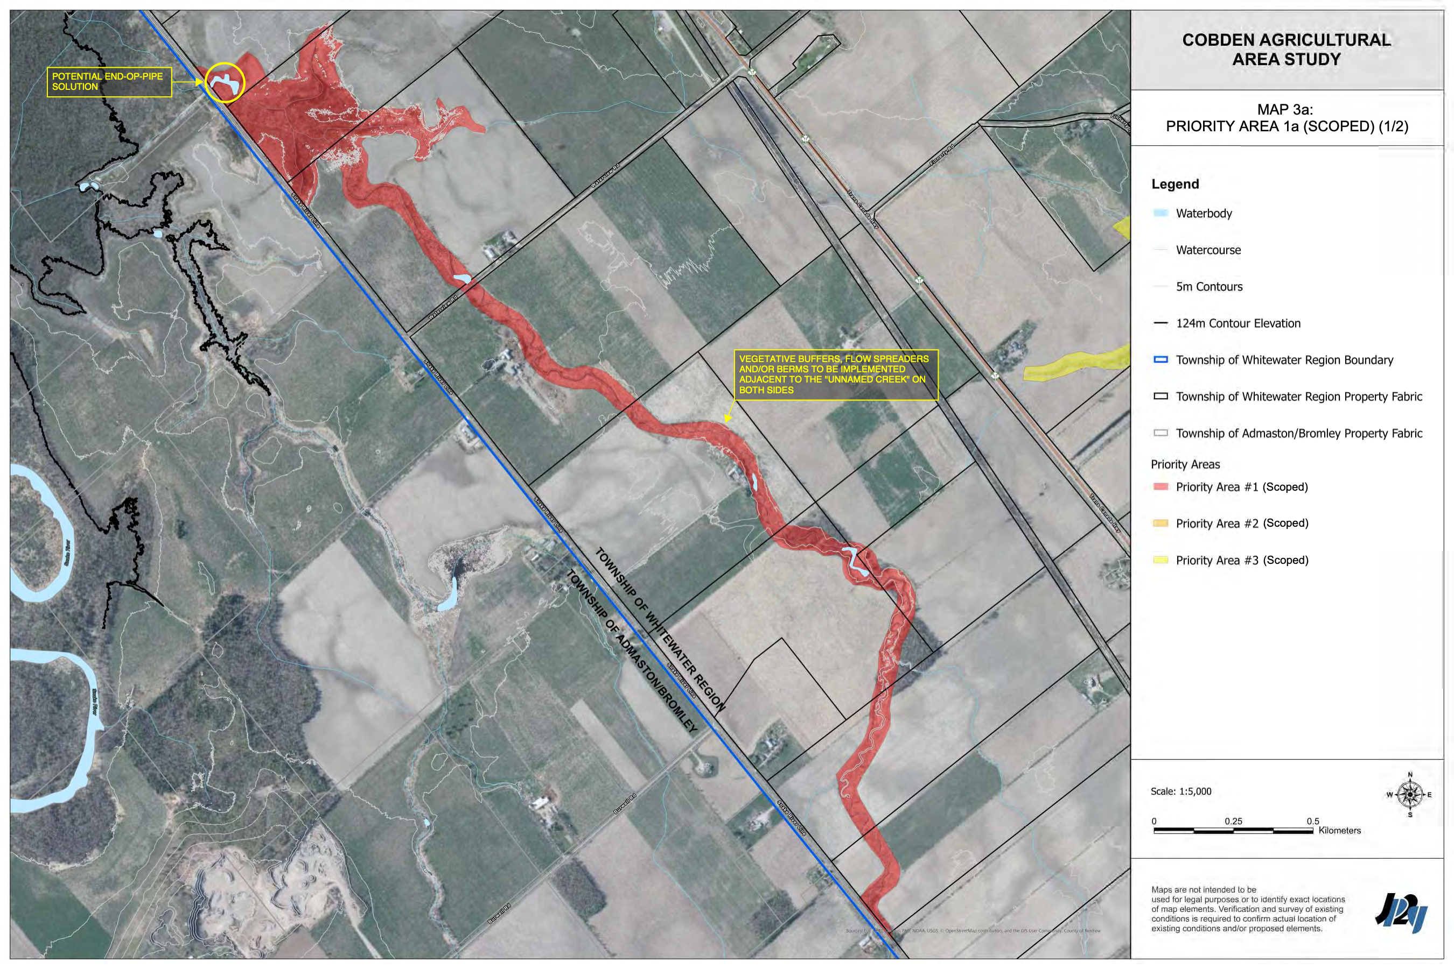
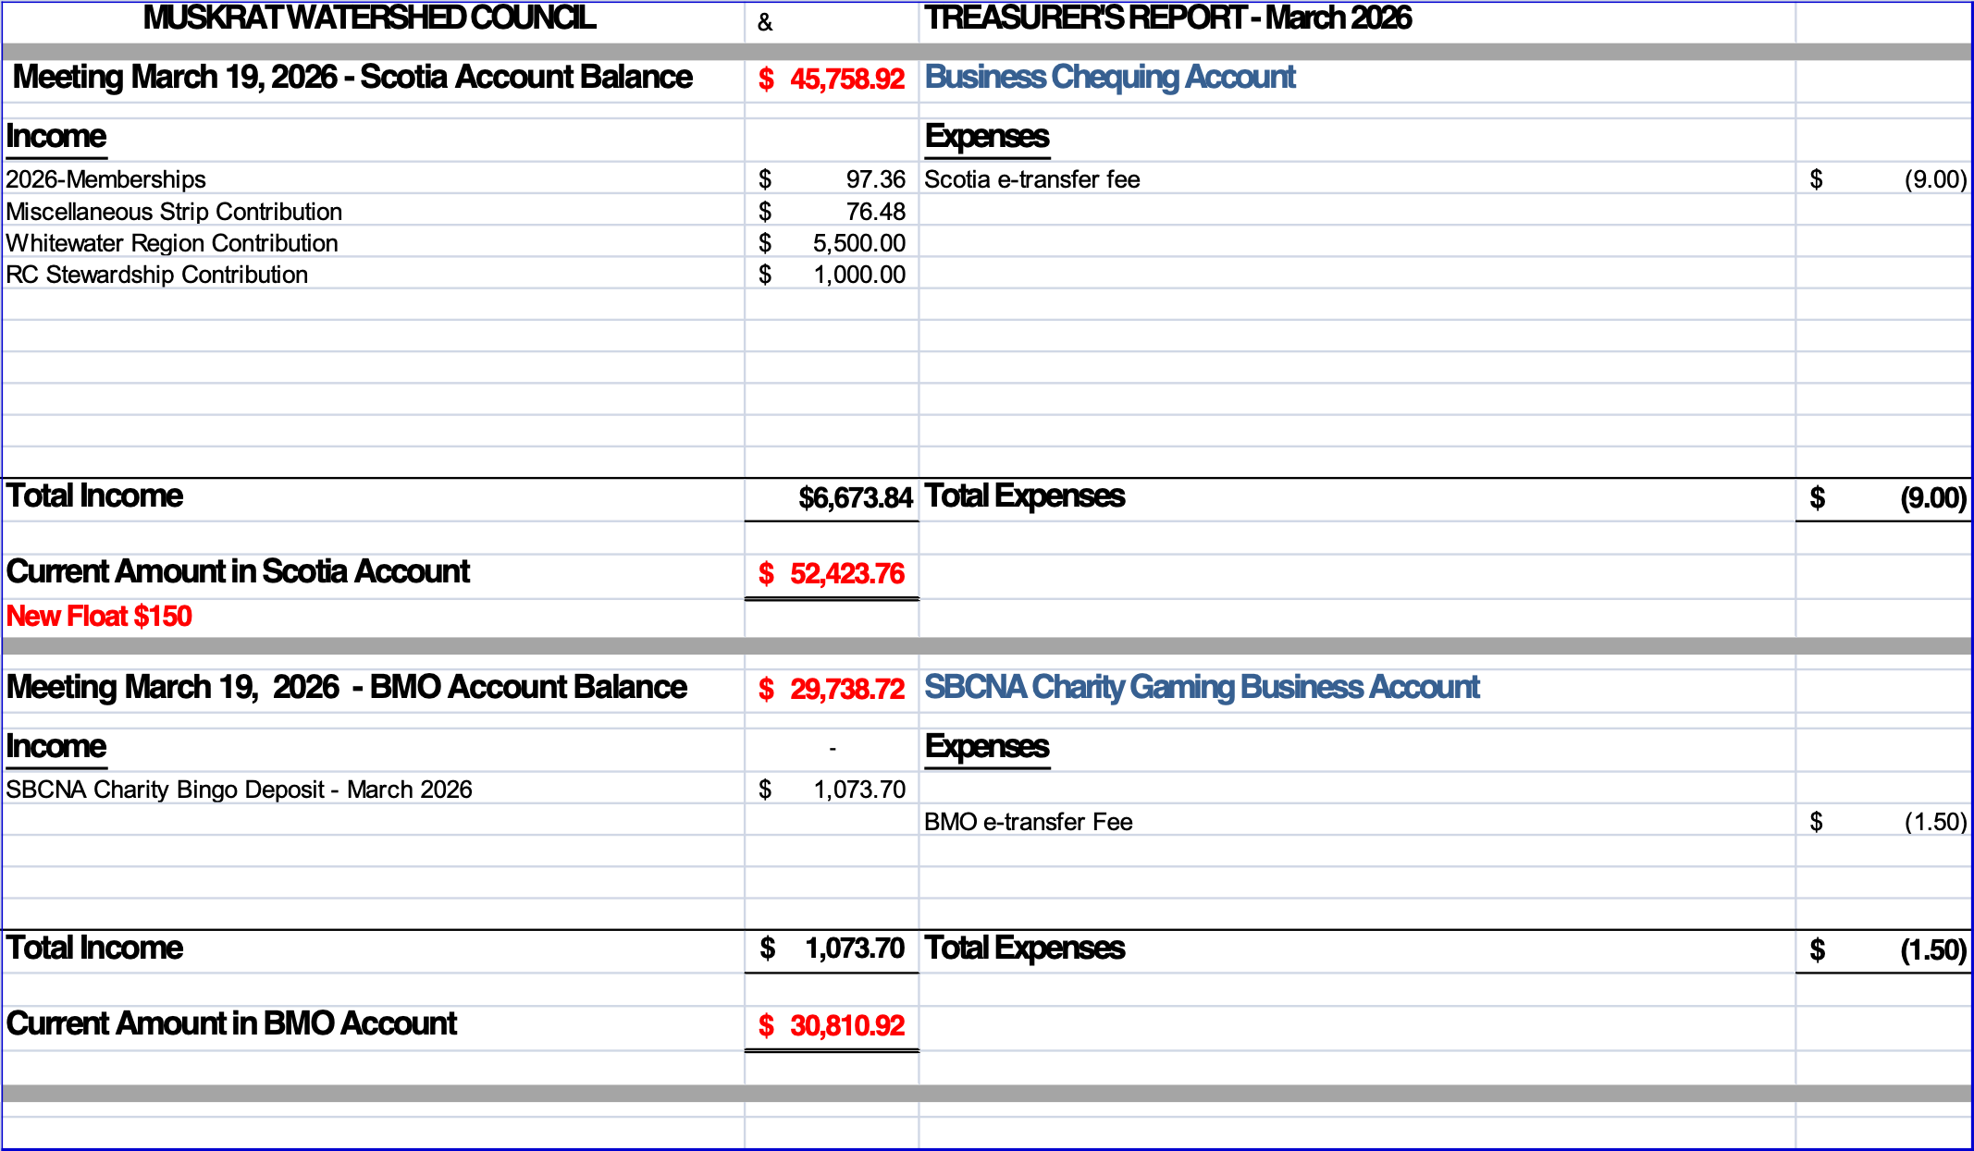
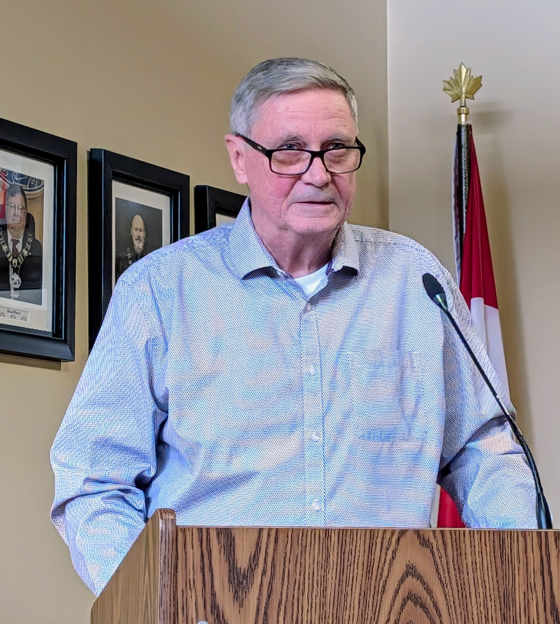
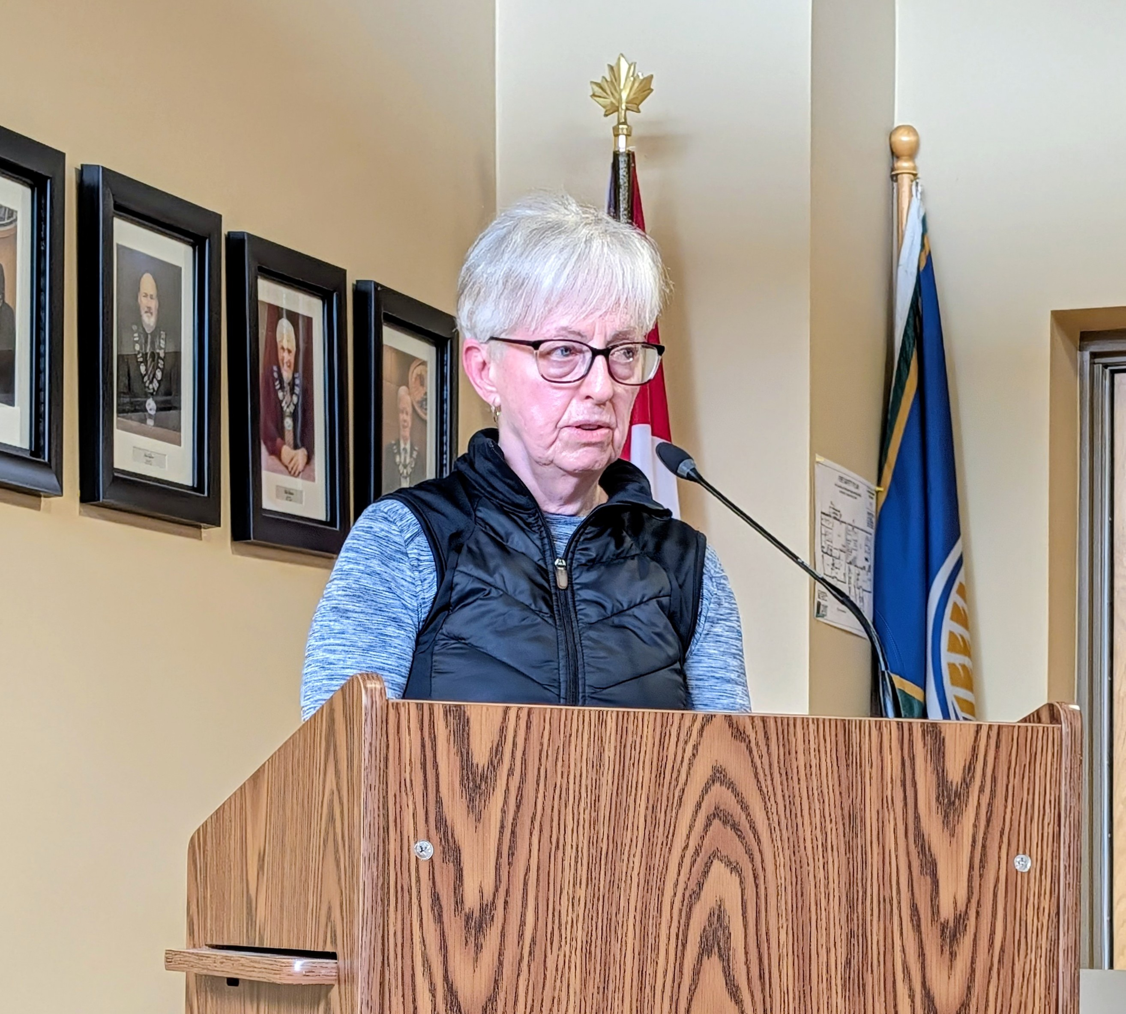

Debbie Macdonald, MWC Treasurer, and Brian Whitehead, MWC Director of Science (Acting) present to the council of the Township of Whitewater Region on April 1, 2026.

